Name: Pranali Sonawane
Subject: CCNA
Lab – HSRP(Hot standby Router Protocol):
First, we have taken one switch, two PCs, and two routers. The PCs are connected to the switch using straight-through cables. The routers are also connected to the switch using straight-through cables.

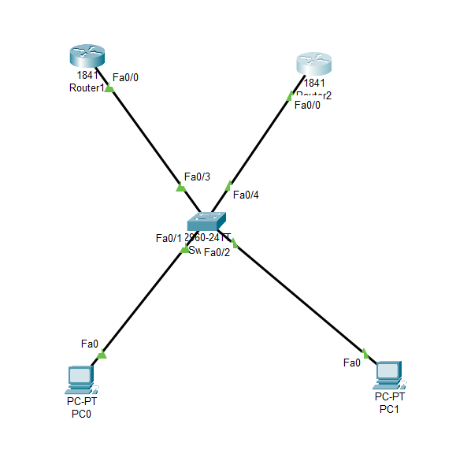

Open Router 0 – CLI prompt then type following commands
Router>enable
Router#configure terminal
Router(config)# interface fastEthernet 0/0
Router(config-if)# ip address 10.0.0.1 255.0.0.0
Router(config-if)#no shutdown
Router(config-if)#ip dhcp pool DHCP
Router(dhcp-config)#network 10.0.0.0 255.0.0.0
Router(dhcp-config)#default-router 10.0.0.1
Router(dhcp-config)# exit
Router(config)# interface fastEthernet 0/0
Router(config-if)#standby ip 10.0.0.10
Router(config-if)#standby priority 110
Router(config-if)#standby pre-empt
Router(dhcp-config)# exit
Router(config-if)#ip dhcp pool DHCP
Router(dhcp-config)#network 10.0.0.0 255.0.0.0
Router(dhcp-config)#default-router 10.0.0.1
Router(dhcp-config)# exit
Router#show standby brief
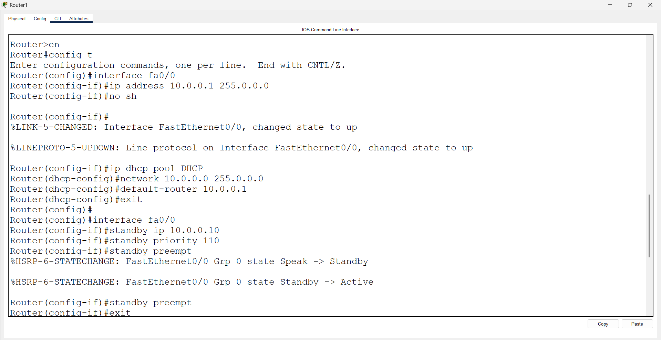
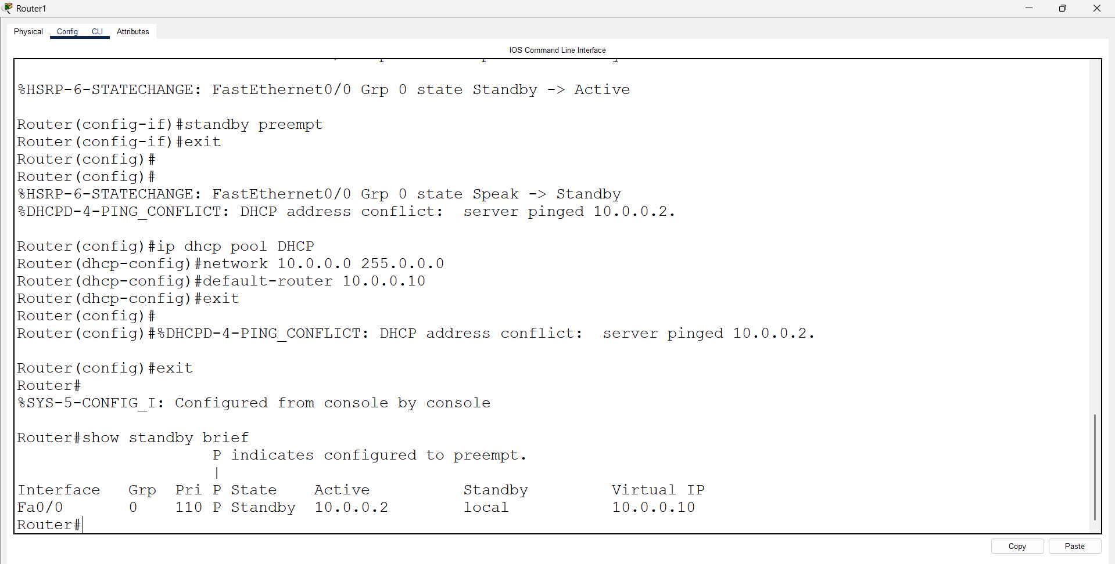
Open Router 1 – CLI prompt then type following commands
Router>enable
Router#configure terminal
Router(config)# interface fastEthernet 0/0
Router(config-if)# ip address 10.0.0.2 255.0.0.0
Router(config-if)#no shutdown
Router(config-if)#ip dhcp pool DHCP
Router(dhcp-config)#network 10.0.0.0 255.0.0.0
Router(dhcp-config)#default-router 10.0.0.1
Router(dhcp-config)# exit
Router(config)# interface fastEthernet 0/0
Router(config-if)#standby ip 10.0.0.10
Router(config-if)#standby priority 120
Router(config-if)#standby pre-empt
Router(dhcp-config)# exit
Router(config-if)#ip dhcp pool DHCP
Router(dhcp-config)#network 10.0.0.0 255.0.0.0
Router(dhcp-config)#default-router 10.0.0.10
Router(dhcp-config)# exit
Router#show standby brief

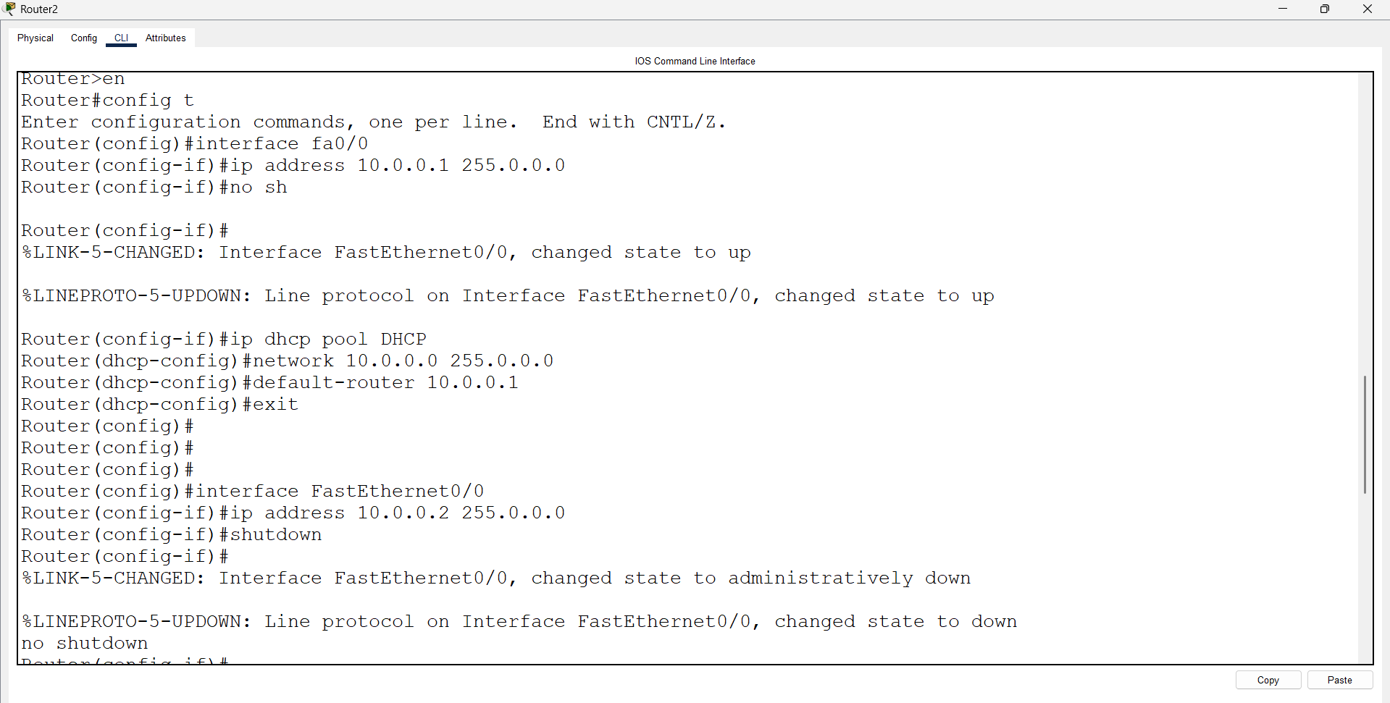

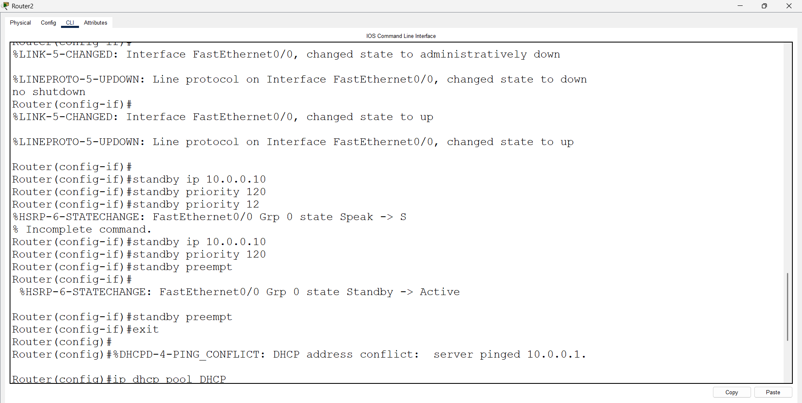
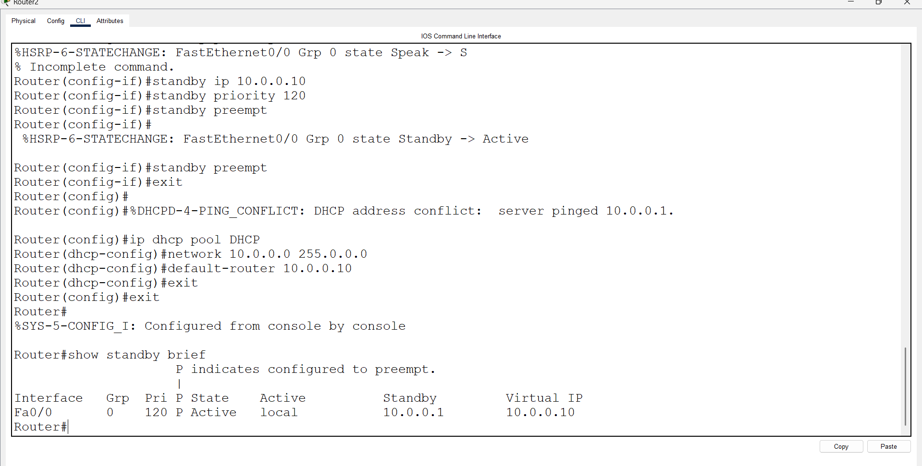Open pc 0 – cmd prompt – type command>ping 10.0.0.10